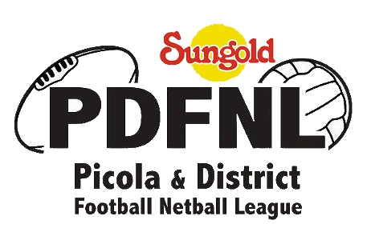

Update PDFNL 2020 Season – Sunday 22nd March 2020

Following a meeting of the PDFNL board on Friday 20th March 2020, the decision has been made to postpone all football and netball competitions until the weekend of Saturday, May 2nd, 2020.

The league will continue to correspond with the various authorities and re-convene by Friday 17th April to review and/or confirm this commencement date, subject to the status of the COVID-19 pandemic.

The decision has been made after ongoing consultation with the office of Federal and state Ministers, Netball Victoria , Netball Australia , AFL , AFLGM, PDFNL clubs and in consideration of the ever changing Federal Government requirements .

The PDFNL advises all of its clubs to remain aware and vigilant of current federal and state government requirements regarding gatherings.

Providing support to PDFNL members along with the many commercial partners who continue to support the PDFNL community is of high priority, during these unprecedented times.

This decision has been reached with consideration to the Health and Welfare of all stakeholders and League and Club Sustainability.

